**Git hub logo**

<http://image.flaticon.com/icons/svg/38/38401.svg>

**Linked in Logo**



<https://upload.wikimedia.org/wikipedia/commons/c/ca/LinkedIn_logo_initials.png>

**Stack Overflow Logo**



<http://sourcingrecruitment.info/wp-content/uploads/2015/05/stackoverflow.png>

Placeholder Images for Portfolio

Web 1 – 5

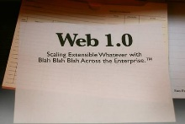

<http://blogoscoped.com/files/web-1-0.jpg>

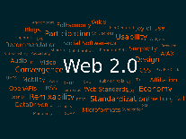

<https://upload.wikimedia.org/wikipedia/commons/thumb/a/a7/Web_2.0_Map.svg/2000px-Web_2.0_Map.svg.png>



[**http://thesardine.co.za/wp-content/uploads/2015/05/web-3.jpg**](http://thesardine.co.za/wp-content/uploads/2015/05/web-3.jpg)



[**https://theawesomeinternet.files.wordpress.com/2010/01/web1.jpg**](https://theawesomeinternet.files.wordpress.com/2010/01/web1.jpg)



[**http://www.herramienta.com.ar/sites/default/files/logo5.jpg**](http://www.herramienta.com.ar/sites/default/files/logo5.jpg)